***N.E.M.***

*N.E.M.*

**Nutrient Enriched Mat**

In order to create this mat, resources found in the area will be used. Clay soil, lalo (jute) plant, and biodegradable waste provided by SOIL, are all resources easily attainable and come at a low cost. SOIL is an organization familiar to the area, who will be partnering with the NEM team. They will provide compost that will be the main source of nutrients that will be implemented in the soil. Using the lalo (jute) plant, a mesh like material will be created in order to hold the compost and clay soil. A layer of lalo will be placed above and below the compost material to allow for adequate binding. A solar powered compressor will press all the materials together, making a long sheet. Thus, creating the nutrient enriched mat, N.E.M.

**Comment fait N.e.m.?**

**how is n.e.m. made?**

Our production team will create sheets of these enriched mats that will be available for purchase based on the size of the farmers land. The mat itself is easy to place over the farming land, and pins (provided with the mat) will hold the mat in place. Over time, as new fresh soil is emerging, the jute will degrade, and only the compost and clay soil will be left to continue to enrich the fresh soil.

**Comment fonctionne n.E.M.?**

**how does N.E.M work?**

N.E.M. is a biodegradable mat that will provide eroded soil with nutrients that will enrich the soil, to allow for crops to flourish for agricultural purposes. Soil erosion has made it difficult for farmers to grow crops and provide food for them and their families. Unfortunately, there hasn’t been a solution that has helped provide nutrients to the soils, until N.E.M. emerged.

**Quel est N.E.M.?**

**What is N.E.M.?**

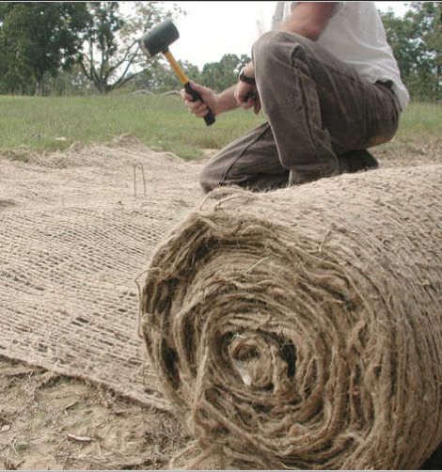  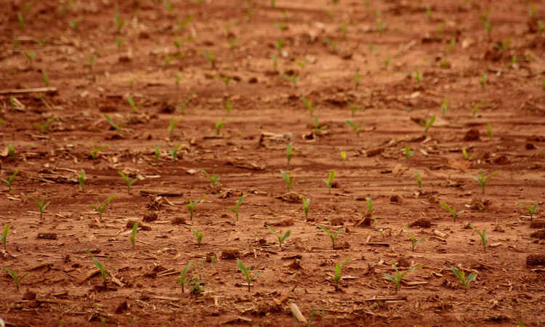

Mats can be purchased to last an entire farming season. Once a new farming season starts, new mats can be purchased once again to enrich the soil. Our team wants to boost the agriculture production to help tackle the food insecurity.

**N.E.M.’s Objectif**

**N.e.m.’s goals**

3rd Layer: Compost and clay

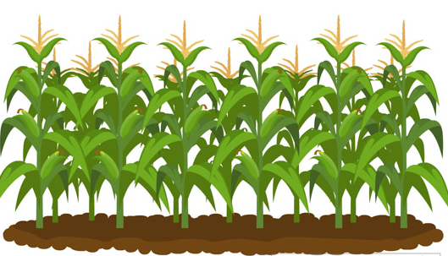

4th Layer: Nutrient rich soil

3rd Layer: Top Jute mesh

1st Layer: Nutrient rich soil

2nd Layer: Compost and Clay soil

4th Layer: Top jute mesh

1st Layer: Eroded soil

2nd Layer: Bottom jute mesh